Ecology (High School)
Version 3
This is a test that will help us to understand what you know about ecosystems. Please answer these questions as carefully and completely as you can. If you are not sure of the answer, please write about any thoughts that you have.

Please put your initials (not your full name) in the boxes
 | First | Middle | Last
Date ________________
Class ____________________________ Teacher ___________________________

1. Think of all the organisms in a growing forest--producers, consumers, decomposers. As the forest grows, which of these statements would you expect to be true?

a. The forest absorbs more carbon dioxide than it releases
b. The forest releases more carbon dioxide than it absorbs
c. The forest absorbs and releases about the same amount of carbon dioxide

Explain your answer.

2. Which of the following are sources of energy for plants? Circle yes or no for each of the following:

a). Water Yes / No
b). Light Yes / No
c). Air Yes / No
d). Nutrients in soil Yes / No
e). They make their own energy Yes / No

Explain what you think is energy for plants.

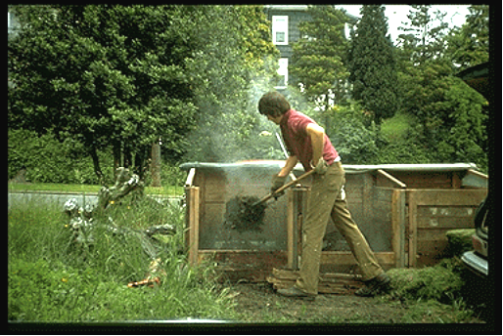
.

Picture 1 Picture 2

3. In autumn, people pile fallen leaves and send them to the trash dump. Picture 2 shows that after several weeks, heat is released from the leaves (the leaves are not on fire). Where does the released heat come from? Please explain your answer.

4. Years ago farmers found that corn plants grew better if decaying fish were buried near by. What did the decaying fish probably supply to the plants to improve their growth? Circle ALL correct answers.
A. Energy
B. Minerals
C. Protein
D. Oxygen
E. Water

Explain your answer to the previous question. How did the things you circled get from the fish to the plant?

5. An ecosystem contains grass, grasshoppers, sparrows, and hawks. Which group of organisms contains the least energy in the ecosystem?
- Grass
- Grasshoppers
- Sparrows
- Hawks
- This question does not provide enough information

Please explain your answer.

6. If we were to weigh all the hawks and all the grass in the ecosystem, which would you expect to weigh more and why?

7. Some scientists have suggested that growing more trees will help to slow down the process of global warming. Why might this be true?

- Trees remove excess carbon from the soil.
- Trees absorb excess carbon dioxide (CO₂) from the atmosphere.
- Trees remove excess water from the soil.
- Trees stabilize soil and prevent erosion.

Please explain your choice

The graph given below shows changes in concentration of carbon dioxide in atmosphere over a 5-year span at Mauna Loa observatory at Hawaii.
8. Why do you think this graph shows atmospheric carbon dioxide levels decreasing in the summer and fall and carbon dioxide levels increasing in the winter and spring?

9. Why do you think levels of carbon dioxide have slowly increased from 1995 to 2001?

